**System Test Case Specification**

* 1. **Test Case Specification Identifier**

TCS-01-02 2014-05-22

* 1. **Test Items**

PlasmaGraph feature “Create Graph” using linear interpolation and determining confidence level **[see *SRS-3-2014-05-15 section 2.2.1.4*]**.

* 1. **Input Specifications**

1. One (1) data file formatted as a binary MATLAB Level 5 MAT-File **[see *SRS-3-2014-05-15 section 2.2.1.1*]** and having the following information:

|  |  |
| --- | --- |
| -- Column --  Name: ExperimentNumber  Type: double  Size: 5  Values: [NaN, 1.0, 1.0, 1.0, 2.0] | -- Column --  Name: CurrentLevelA  Type: double  Size: 5  Values: [50.0, 100.0, 150.0, 200.0, 250.0] |
| -- Column --  Name: Temperature2eV  Type: double  Size: 5  Values: [27.673172, 7.944175, 9.140306, 9.354156, 8.108458] | -- Column --  Name: PlasmaPotential2V  Type: double  Size: 5  Values: [44.4, 11.6, 12.8, 13.2, 12.0] |

1. One (1) column for the X axis. The variable selected must be Temperature2eV.
2. One (1) column for the Y axis. The variable selected must be PlasmaPotential2V.
   1. **Output Specifications**
3. The system must show a message informing the user that the graph “Temperature2eV vs PlasmaPotential2V” confidence level is 99%.
4. The system must produce a graph with the following points plotted:

|  |  |
| --- | --- |
| Axis X | Axis Y |
| 7.944 | 11.6 |
| 8.108 | 12 |
| 9.14 | 12.8 |
| 9.654 | 13.2 |
| 27.673 | 44.4 |

1. The graph must look like this:

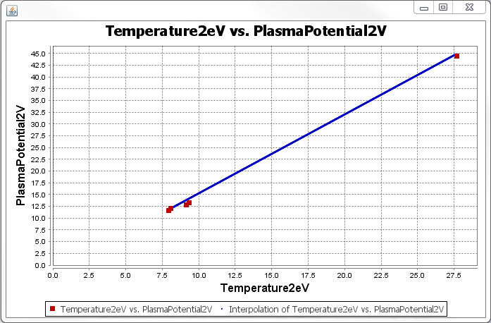

* 1. **Environmental Needs**
  2. **Hardware**

A personal computer with the following minimal specifications is required to execute this case:

* 15’’ Monitor with a resolution of 1200x700 and refresh rate of 30Hz
* A standard alphanumeric American (QWERTY) keyboard
* Two 3.20Ghz microprocessors
* 500Mb of available HDD
* 512Mb of RAM
* One (1) USB 2.0 port
  1. **Software**

PlasmaGraph must be installed in the tester’s computer in order to perform this test case.

* 1. **Special Procedural Requirements**

This case must be executed in three (3) different operative systems as stated in the documentation STD-2-2014-05-15 these operative systems are:

1. Windows 7
2. Ubuntu Linux 14
3. Mac OS X 10